Operating Systems

Lab 2a – The File System and related commands

Aim : To understand the UNIX File System

(N.B. Read through the entire document before attempting any of the tasks.)

The UNIX file system is very similar to the DOS file system (from a user perspective). During this lab session, we will study the UNIX Logical file system - the physical file system will be studied later in the course when we have studied how an operating system implements a file system.

In UNIX, a file is simply a collection of information with no attached meaning. UNIX imposes no rules about what a file should contain - it is the responsibility of the application that owns the file to dictate the internal format of the file. We say that the file is structureless.

Files are grouped together and stored in directories. A directory is a special sort of file. It can contain ordinary files or additional directory files.

The UNIX directory structure is hierarchical - the files are organised using an upside-down hierarchical tree structure with the root at the top. All files have a parent file, apart from a directory called the root directory, which is the parent of all files on the system. This is similar to the DOS directory structure.

The root directory is referred to by / (forward slash).
In order for the machine to know how to find the data in these directories, each has a file, called dot (.), which stores information about that directory (such as the files stored within it, how big they are and where on disk they are stored). The word directory is also used to describe a file such as dot which contains all the information for a directory storage area.

In each directory, in addition to the file dot, is a file called dotdot (..) which is a synonym for the parent of that directory in the tree.

In summary, the UNIX file system exhibits the following four characteristics:

Hierarchical
- The files are organised using an upside-down hierarchical tree structure

Structureless files
- The contents of the files have no meaning to UNIX

Dynamic file expansion
- The size of the file system is restricted only by the amount of disk storage that is available on the system. A file’s size can be changed at will by the user, at any time

Security
- Files are protected using file ownership mechanisms. These allow only a specific class of user to access certain files.

A typical UNIX filestore will be organised into a tree structure looking something like

/ (root)

bin usr etc tmp lib

bin users lib

The directory structure is determined primarily by the system administrator when the system is being configured. A user can then create their own directory structure under their own directory.

When you login to UNIX, you are assigned a home directory. If you do not know the name of your home directory, you can find out what it is by typing the command pwd immediately after logging on.

- pwd (print working directory) prints the working (current) directory on the screen so that you know where you are.

At all times you can access files in one particular directory, which is called the current or working directory. It is also possible to move between different directories, thus changing the current directory.

- To move around directories the cd (change directory) command is used (just like in DOS).

Change to the root directory by typing the command cd / then verify that you are in the root directory by using the pwd command.
At any time, you can get back to your home directory by typing the cd command with no parameter. Try this now and use the pwd command to verify that you are in the expected directory.

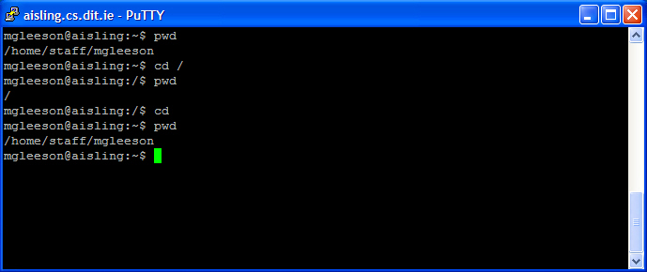

The general form of the cd command is cd [pathname]

- Where path specifies the name of the directory to change to (Specifying directories will be dealt with later in this lab).

N.B. A common mistake when using UNIX is to use \ instead of / when specifying path names. See what happens when you make this mistake!

Rules for UNIX file names

The naming conventions for files and directories are the same (remember, a directory is a special kind of file). When naming a file or a directory

- UNIX allows up to 14 characters for a file name

- Avoid beginning your file or directory names with an underscore
- Avoid characters with special programming or system meanings such as *, ?, [,],-,$,’,”,&,!,/, as they can make file processing difficult and confusing.
- Remember, UNIX is case-sensitive so upper and lower case letters are distinct
- Do not use spaces or periods (.) and (..) for file or directory names
- Filename extensions can be of any length, and program extensions such as .com,.exe, .bat are not required by the UNIX system. Compilers and applications software have their own conventions .c - c program source file etc.
- If a period is used in a file or directory name, it has no special meaning to the system.

Listing files within a directory

To see if there are any files within a directory, type the command ls. Change to the /usr directory and type ls.

The general format of the ls command is

- ls [pathname] where pathname specifies the directory to be listed. If no pathname is specified, then ls will display files in the current directory.

This form of the ls command displays just the names of the files in the specified directory. Like other UNIX commands, ls can take several options - for a full listing refer to the man pages for ls.

One option that is particularly useful is -l. This provides a full (or long) listing.
Several columns of information are displayed for each file when you do a full listing:

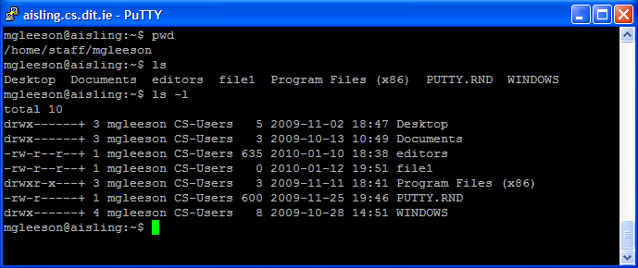

-rw-r--r-- + 1 mgleeson CS-Users 635 2010-01-10 18:38 editors

The first column (which consists of a set of character codes) determines the permitted access rights over the file. This will be covered in more detail in a later class. For now, the most relevant character is the first character. In UNIX, directories as well as all devices including disk drives and printers are considered to be files. The first character in the ls listing tells you what the entry refers to:

d => a directory
c => a character device such as a printer or terminal (tty)
b => a block device such as a disk drive
- => an ordinary file

The third column (mgleeson in the above listing) specifies the userid of the owner of the file.

The fifth column (635 in the above listing) specifies the length of the file in bytes.

The sixth column (2010-01-10) specifies the date and time of the most recent update.

The seventh column (editors in the above listing) specifies the name of the file.

Dot files

Change to your home directory and type ls. Staying in your home directory, type the command ls -a. Notice that the second command results in a lot more files being displayed than the first.

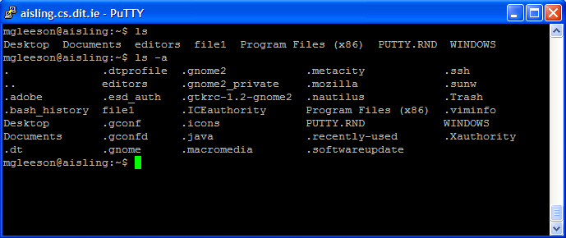

These ‘hidden’ files all have names beginning with a dot. You will recognise . and .. but there are other files beginning with . too. e.g. .dtprofile, .gnome2, .ssh; these files are all used by a UNIX utility to enable you to customise that utility. The man pages for that utility will explain what data it should contain. NEVER delete or edit a dot-file unless you know what it should contain, even if it is empty.

Subdirectories and Pathnames

There are two ways of referring to a file:
Relative path - this specifies the name of the file relevant to the current directory i.e. we only need to use the name of the file and it is assumed that it is in the current directory.

Absolute path - this specifies the name of the file relative to the root. i.e. We need to specify how to get to the file starting at the root directory. In this case, its name begins with a / , followed by the intervening directories between the root and the file separated by /’s, and finally ending with the filename.

If a filename commences with the character / then it is an absolute name, otherwise it is relative.

The home directory has a synonym ~ which you can use, no matter where you are in the directory structure, whenever you need to refer to your home directory. This saves time typing the absolute path name to your home directory.

Some other UNIX Commands

Create a text file as you did in lab 1 and save it as filename1
Run the following Commands.
You can call the new director lab 2

The following commands are for manipulating directories and files. They work just as their DOS counterparts do. Practise using them so that you become familiar with them.

- mkdir dirname
Creates a directory called dirname

From your home directory, make a directory called mydir and create two files called file1 and file2.

- rmdir dirname

Destroys the directory called dirname. rmdir will only work if the directory that you are trying to remove contains no user files.

- cp filename1 filename2
Copies filename1 to filename2

Copy file1 and file2 to the mydir directory, then try to remove the mydir directory using rmdir.
- mv filename1 filename2
Renames filename1 to filename2

In mydir, rename file1 to be file3.

- head filename
Shows the first few lines of file filename

Run head against file1.

- tail filename
Show the last few lines of file filename

Run tail against file1.

- touch filename
Updates file last access and last modification date/ time of file filename. Will create an empty file if filename does not exist but won’t affect the contents of an already existing file.

- rm filename
Deletes the file filename

- df
Displays the disk space used in the system

Wildcard Characters

The wild card characters (* and ?) work exactly as they do in DOS and can be used with many UNIX commands.

* - match any combination of characters
? - match one individual character

Files beginning with a range of characters can be selected for listing by enclosing the range within square brackets.

To list all files beginning with the letters a to b, type ls [a-b]*

Use the tables below to discover how to manipulate the UNIX File System further

